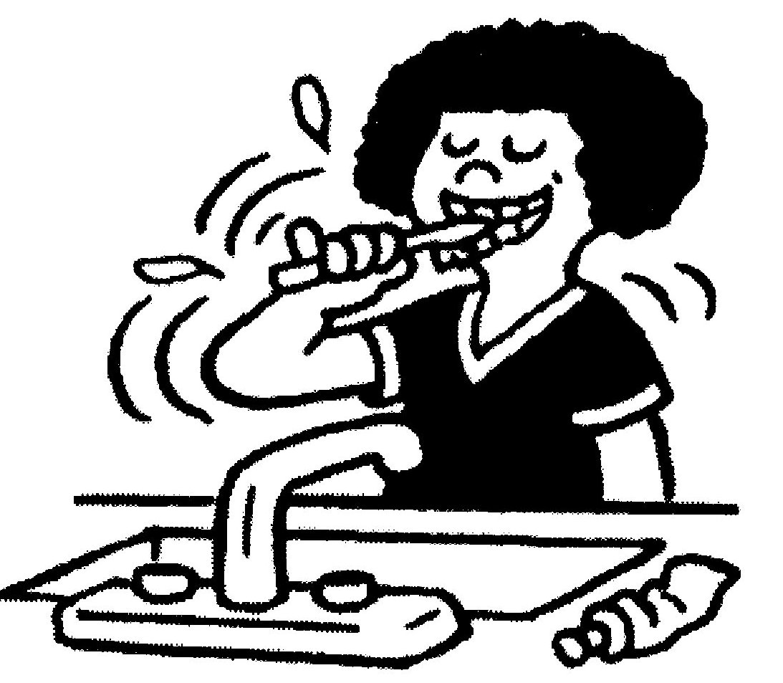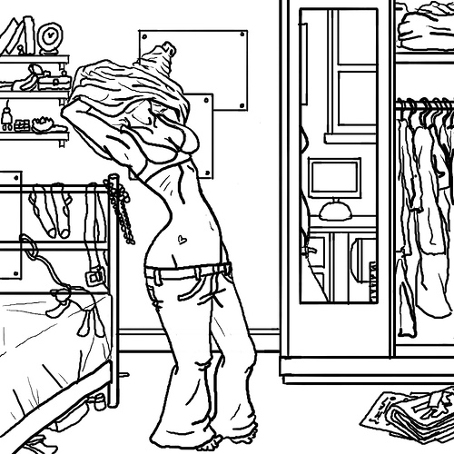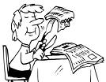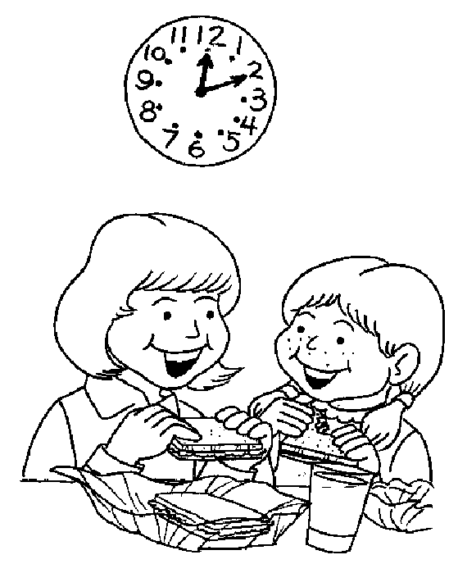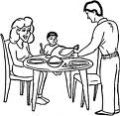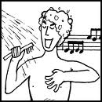

**14. Wake up**

**1. Take a shower**

**16. Brush (my) teeth**

**20. Shave**

**2. Comb (my) hair**

**5. Put on makeup**

**13. Get dressed**

**4. Have breakfast**

**9. Go to school / work**

**3. Have lunch**

**6. Go shopping**

**8. Go back home**

**19. Do the housework**

**17. Do the homework**

**7. Cook**

**18. Have dinner**

**12. Watch TV**

**15. Read a book**

**11. Take a bath**

**10. Go to bed**

